# NFC Read/Write and Bluetooth LE Communication System

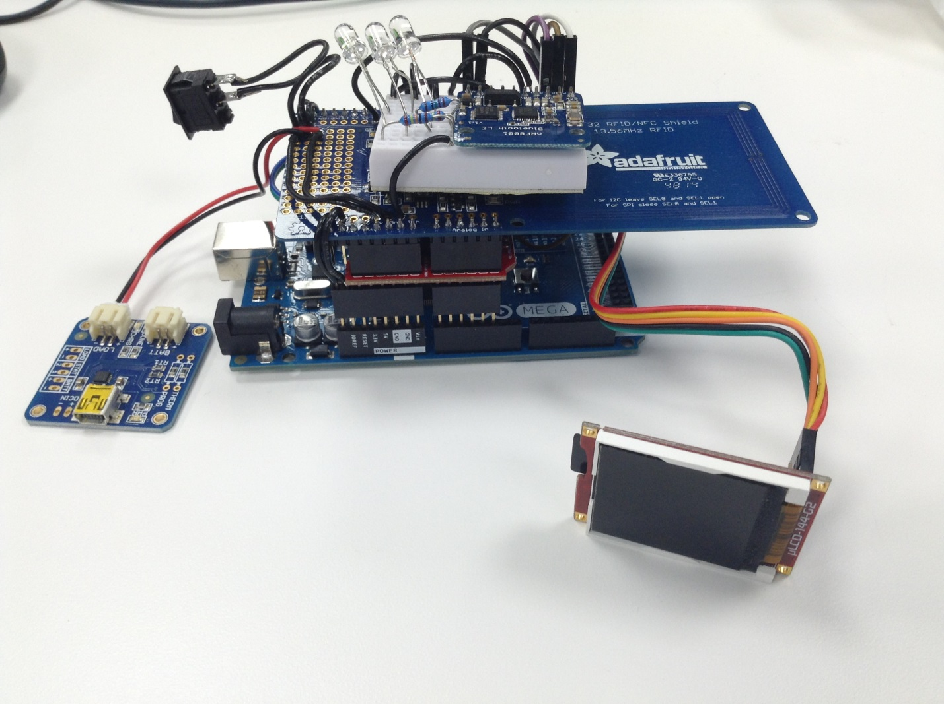

6

5

4

3

2

1

## Main components/boards

|  |  |
| --- | --- |
|  | [Arduino Mega R3](https://www.arduino.cc/en/Main/ArduinoBoardMega2560) |
|  | [Adafruit PN532 NFC/RFID shield](https://www.adafruit.com/product/789) |
|  | [Bluefruit LE - Bluetooth Low Energy (BLE 4.0) - nRF8001 Breakout - v1.0](https://www.adafruit.com/products/1697) |
|  | [USB LiIon/LiPoly charger - v1.2](https://www.adafruit.com/products/259) |
|  | [Display Modules 1.44" LCD Pk Arduino w/ adptr shld+cable](http://www.4dsystems.com.au/product/uLCD_144_G2_AR/) |
|  | [SPST On Off Black Snap in Boat Rocker Switch](http://www.amazon.com/250V-125V-Solder-Rocker-Switch/dp/B008LT3O14/ref=pd_sim_60_4?ie=UTF8&refRID=0M0JV63K9QSE1ESENQY5) |

## Software required

|  |  |
| --- | --- |
|  | [Arduino IDE (latest)](https://www.arduino.cc/en/Main/Software) |
|  | [4D Systems Workshop4 IDE](http://www.4dsystems.com.au/) |
|  | An iOS Bluetooth app for testing. For eg., [Adafruit Bluefruit LE Connect](https://itunes.apple.com/us/app/adafruit-bluefruit-le-connect/id830125974?mt=8) and [nRF MCP](https://itunes.apple.com/us/app/nrf-connect/id1054362403?mt=8) |

You can find more information including the **libraries** and **tutorials** by clicking on the links above.

## Functions

### Arduino Mega R3

This is the development board. It’s the main board interfacing with all other components/boards. I think of it as the “brain” of the system. Once all the setup work such as assembly, wiring, library installations, programming Arduino is done, Arduino and other components/boards can start communicating with each other.

### Adafruit PN532 NFC/RFID Shield

This shield is the NFC/RFID controller and antenna. It retrieves the data such as the **UID** and **block data** from NFC tags. It communicates with **13.56MHz RFID/NFC tags**. It doesn’t work with tags on metal.

### Bluefruit LE - Bluetooth Low Energy (BLE 4.0) - nRF8001 Breakout - v1.0

This breakout board is the Bluetooth Low Energy module and antenna. It broadcasts its advertisement data and connects with a host (Bluetooth scanner). It’s the main form of communication between the system and the host. It can send out data packets (bytes) to the host and receives data packets from the host. For this project, it transmits the NFC data and acknowledge signals to the host. It also receives the data such as text, id, image files and sound files and request signals from the host.

### USB LiIon/LiPoly Charger - v1.2

This is the charger for a Li-ion/Li-poly 3.7V/4.2V rechargeable battery. The rechargeable battery can be used to power the system. Connect the battery to the “BATT” connector. You can turn on and off the charger by flipping the rocker switch. To charge the system, connect a USB cable to the charging port.

## Powering The System

There are three options to power up the system.

### USB

This requires a USB type B cable.

### DC Barrel Power Jack

This requires a 7-12V AC-DC power adapter.

### Li-ion/Li-poly Rechargeable Battery

To turn on and off the system, flip the rocker switch. See Section USB LiIon/LiPoly Charger – v1.2.